Import java.util.Scanner;

Public class SalaryCalculator {

Public static void main(String[] args) {

Scanner sc = new Scanner(System.in);

//System.out.print(“Enter hourly wage: “);

Double wage = sc.nextDouble();

If (wage < 0) {

System.out.println(“Hourly wage cannot be negative.”);

Return;

}

//System.out.print(“Enter hours per week: “);

Int hPerWk = sc.nextInt();

If (hPerWk < 0) {

System.out.println(“Hours per week cannot be negative.”);

Return;

}

//System.out.print(“Enter weeks worked: “);

Int wks = sc.nextInt();

If (wks < 0) {

System.out.println(“Weeks worked cannot be negative.”);

Return;

}

Double wkSal;

If (hPerWk > 40) {

Double regHrs = 40;

Double ovtHrs = hPerWk – 40;

wkSal = (regHrs \* wage) + (ovtHrs \* wage \* 1.5);

} else {

wkSal = hPerWk \* wage;

}

If (hPerWk < 20) {

wkSal \*= 0.9;

}

Double totSal = wkSal \* wks;

System.out.printf(“Total salary is %.1f\n”, totSal);

}

}

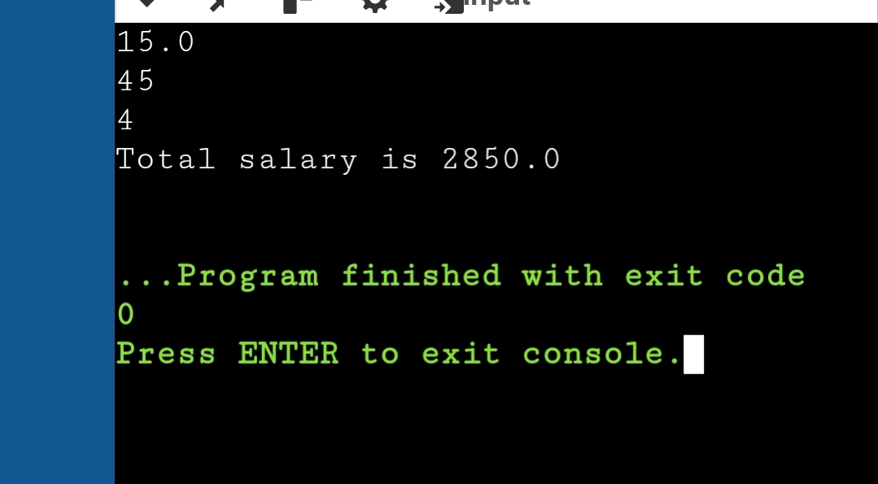

Import java.util.Scanner;

Public class TicketCalculator {

Public static void main(String[] args) {

Scanner sc = new Scanner(System.in);

System.out.print(“Enter ticket type (Regular, VIP, Premium): “);

String type = sc.nextLine().trim();

System.out.print(“Enter number of tickets: “);

Int qty = sc.nextInt();

If (qty < 0) {

System.out.println(“Number of tickets cannot be negative.”);

Return;

}

Double pricePerTicket = 0.0;

Double discount = 0.0;

Switch (type) {

Case “Regular”:

pricePerTicket = 50.0;

if (qty > 10) discount = 0.10;

break;

case “VIP”:

pricePerTicket = 100.0;

if (qty > 5) discount = 0.15;

break;

case “Premium”:

pricePerTicket = 150.0;

if (qty > 3) discount = 0.20;

break;

default:

System.out.println(“Invalid ticket type.”);

Return;

}

Double totalCost = qty \* pricePerTicket;

totalCost -= totalCost \* discount;

if (totalCost < 200) totalCost += 20;

System.out.printf(“%.1f\n”, totalCost);

//sc.close();

}

}

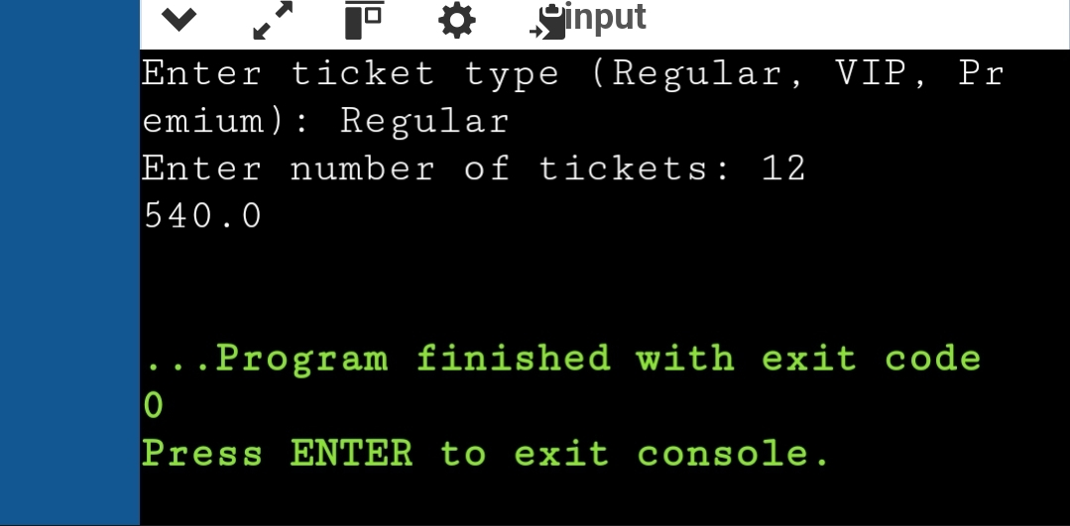

Import java.util.Scanner;

Public class DigitExtrema {

Public static void main(String[] args) {

Scanner sc = new Scanner(System.in);

System.out.print(“Enter a number: “);

Int n = sc.nextInt();

If (n < 1 || n > 10000) {

System.out.println(“Number out of range.”);

Return;

}

Int minDigit = 9;

Int maxDigit = 0;

While (n > 0) {

Int digit = n % 10;

If (digit < minDigit) minDigit = digit;

If (digit > maxDigit) maxDigit = digit;

N /= 10;

}

System.out.println(minDigit + “ “ + maxDigit);

//sc.close();

}

}

